Warehouse Project

Assumptions:

We are assuming that this warehouse is only open 8 hours a day to cover all trucks that may arrive during working hours even though there are truck drivers that drive all night long and arrive at warehouses at any time of the day. With this assumption of the warehouse being open for only 8 hours, then the 48-time increments mean crates are being unloaded every ten minutes. In addition, we noticed trucks do not all arrive at a single time. Trucks can arrive more often around a certain time point during the day and arrive rarely during other times. Our simulation accounts for this by having trucks arrive more often during the middle of the day than at the end of the day to create a more natural truck generator. In our simulation, we adjusted the optimization of the dock lines so that new trucks will join a dock not currently unloading a truck, or if the docks are all unloaded, it will join the shortest line available.

Results:

Since the results can be skewed by a random outlier simulation, and to adjust for any potential discrepancies, we ran the simulation three times for each dock size that we tested. The dock sizes we tested ranged from 5 to 12. The most profitable number of docks in this simulation was when there were 10 docks in play. The amount of total profit increased from 5 docks to 10 docks, and then the profits sharply drop back down from 10 to 12 docks. With 5 docks in place, total profits tended to be about $27,000. The profit level rose from 5 docks to 10 docks with a profit of about $42,000. The total operating cost also increased drastically from $28,800 for 5 docks to $48,000 for 10 docks. Per our analysis from above, we recommend for the company to use no more than 10 docks to keep their profits up high. Any more docks than that reduces the profits back down to be about the same as operating with only 5 docks.

Some figures from our simulations:

Figure 1: shows the output for a dock size of 5.

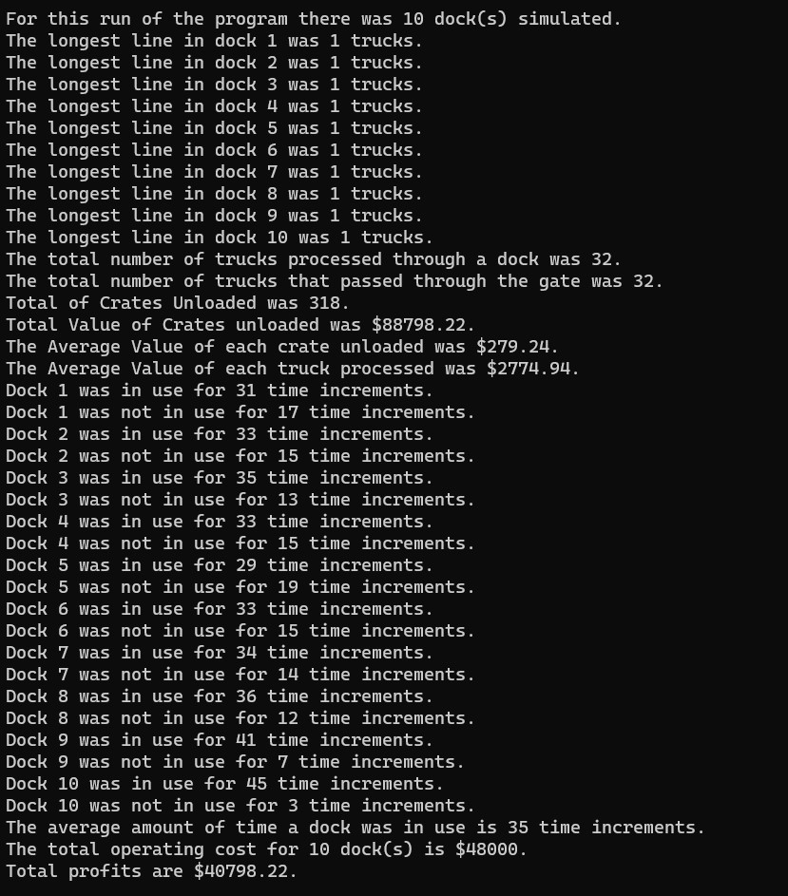

Figure 2: shows the output for a dock size of 10

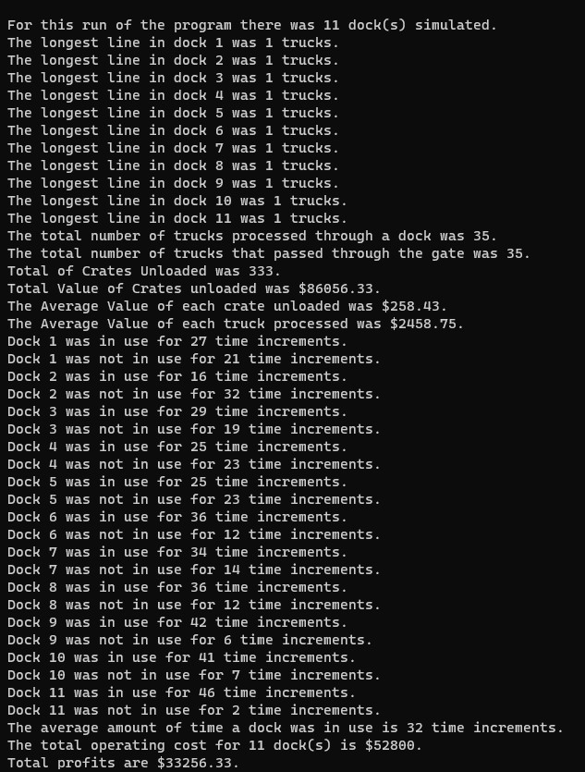

Figure 3: shows the output for a dock size of 11